PySpark
APACHE SPARK
Apache Spark is an open-source distributed computing framework used to process and analyse large amounts of data quickly. Spark allows us to process huge datasets by dividing the work across multiple computers/CPU cores and processing the data in parallel.
Spark is designed to handle large-scale data processing.
Spark can be used for:
- Data cleaning, Data transformation, ETL pipelines, Data analysis, SQL queries, Machine learning, Streaming data, Large-scale data processing.
Spark Core:
- Spark Core is the foundation of Apache Spark.
- It handles the basic operations needed to run Spark applications, such as task scheduling, memory management, and fault recovery.
- Example: If Spark needs to process a large dataset by splitting the work into tasks, Spark Core helps coordinate that work.
RDD (Resilient Distributed Dataset):
- An RDD is a collection of data distributed across multiple partitions that Spark can process in parallel.
- Resilient: Can recover lost data through recomputation.
- Distributed: Data can be spread across partitions and machines.
- Dataset: A collection of data.
Think of an RDD as a basic distributed collection of data. In modern PySpark applications, DataFrames are generally preferred for structured data.
DataFrame:
- A DataFrame is a distributed collection of data organized into named columns, similar to a table in SQL or a DataFrame in Pandas.
- Eg. df.filter(df.Salary > 30000).show()
Spark SQL:
- Spark SQL allows you to process structured data using SQL queries.
- Think of Spark SQL as using familiar SQL commands to analyze large datasets with Spark.
Spark web UI:
- The Spark Web UI is a browser-based dashboard for monitoring Spark applications.
- It helps you inspect:
- Jobs and stages
- Tasks and their execution times
- Executors and memory usage
- Failed tasks
- Data shuffles and performance bottlenecks
- Think of it as a monitoring dashboard that shows what Spark is doing behind the scenes.
Structured Streaming:
- Structured Streaming processes data continuously as new records arrive.
- Traditional batch processing handles data that has already been collected. Streaming processes incoming data incrementally.
- Example: A payment company receives thousands of transactions every second.
- Think of it as analyzing data while it is arriving, rather than waiting for all the data to be collected.
Machine Learning Library:
ML-Lib provides machine-learning functionality within the Spark ecosystem.
It supports tasks such as:
- Classification
- Regression
- Clustering
- Feature processing
- Recommendation algorithms

PySpark
Apache Spark vs PySpark
1. Apache Spark
- Apache Spark is an open-source distributed data processing framework used to process large amounts of data efficiently.
- implemented in Scala.
- It supports multiple programming languages, including Python, Scala, Java, and R.
- Scala is a programming language that runs on the Java Virtual Machine (JVM).
2. PySpark
- PySpark is the Python API for Apache Spark.
- It allows developers to use Spark's distributed computing capabilities using Python.
- It provides Python functions and methods to process large datasets without writing Spark applications in Scala.
3. Python API
- An API (Application Programming Interface) allows one software component to interact with another.
- PySpark provides a Python interface to Apache Spark.
- Using PySpark, we can write Python code to perform distributed data processing through Spark.
Example:
df = spark.read.csv("sales.csv", header=True, inferSchema=True)
df.show()
4. Capabilities of PySpark
- Distributed Computing: Processes data across multiple machines or cores.
- Data Processing: Reads, filters, sorts, and transforms large datasets.
- Data Cleaning: Handles missing values, duplicates, and incorrect data.
- Data Analysis: Performs aggregations, calculations, and statistical operations.
- Spark SQL: Supports SQL queries on structured data.
- Machine Learning: Provides machine-learning tools through MLlib.
- Streaming: Processes continuously arriving data using Structured Streaming.
- ETL Pipelines: Extracts, transforms, and loads data between systems.
5. PySpark and Pandas
- Both PySpark and Pandas provide DataFrame APIs for working with tabular data.
- Their syntax is similar for many common operations, such as filtering, selecting columns, and grouping data.
- Pandas primarily processes data on a single machine.
- PySpark is designed for distributed processing and large-scale datasets.
Example:
Pandas:
df[df["salary"] > 30000]
PySpark:
df.filter(df.salary > 30000)
Key difference: Pandas is commonly used for small-to-medium datasets, while PySpark is particularly useful when data volume or processing requirements call for distributed computing.
6. Applications of PySpark
- Big Data Analytics: Analyzing millions or billions of records.
- Data Engineering: Building scalable data processing pipelines.
- ETL Processing: Extracting, cleaning, transforming, and loading data.
- Data Cleaning: Preparing raw data for analysis and machine learning.
- Business Intelligence: Processing sales, customer, and financial data for reports and dashboards.
- Machine Learning: Preparing large datasets and building scalable machine-learning workflows.
- Real-Time Analytics: Processing streaming events, such as transactions and application logs.
- Log Analysis: Analyzing server logs, application events, and system activity.
- Recommendation Systems: Processing user activity and product interaction data.
- Fraud Detection: Analyzing large volumes of transactions to identify suspicious patterns.

Started Working With Google Colab.
Dataset from the site - https://www.nyc.gov/site/tlc/about/tlc-trip-record-data.page

- from pyspark.sql import SparkSession
Explanation:
- pyspark.sql: Module for working with structured data using PySpark.
- SparkSession: The entry point for creating DataFrames and executing Spark SQL queries.
In simple terms: It imports SparkSession so you can start working with PySpark.

- count() – Returns the total number of rows in a DataFrame.
- df.schema.names – Returns a list of column names.
- printSchema() – Displays column names, data types, and whether columns are nullable.
- describe() – Returns summary statistics such as count, mean, standard deviation, minimum, and maximum for numeric columns.
- select() – Selects specific columns from a DataFrame.
df.select("name", "salary")
- show() – Displays the DataFrame contents in tabular format.
df.show()
- sort() – Sorts the DataFrame by one or more columns in ascending order by default.
df.sort("salary")
- Descending order:
df.sort("salary", ascending=False)
- filter() – Selects rows that satisfy a specified condition.
df.filter(df.total_amount > 100).show()

Handling Missing Data
- Check missing values using isNull()
from pyspark.sql.functions import col
df.filter(col("total_amount").isNull()).show() - Returns rows where total_amount is NULL.
- Fill missing values using fillna()
df.fillna(0, subset=["total_amount"]).show() - Replaces NULL values in total_amount with 0.
- withColumn() - Adds a new column or updates an existing column in a DataFrame.

df1 = df.withColumn("new_column", col("fare_amount") * 2)
- withColumnsRenamed() - Renames multiple columns using a dictionary of old names and new names.
df2 = df.withColumnsRenamed({
"PULocationID": "pu_loc_id",
"DOLocationID": "do_loc_id"})
- drop() – Removes one or more columns from a DataFrame.
df.drop("fare_amount").show()

UNIONS AND JOINS
Unions – union() combines rows from two DataFrames with compatible schemas. It matches columns by position, not by name, and retains duplicates.
Joins - join() combines columns from two DataFrames based on a matching condition.

AGGREGATE FUNCTIONS
- Aggregate functions summarize data across multiple rows and return a single value or grouped results.
- Function | - Purpose | - Example
- count() | - Counts rows or non-null values | - count("passenger_count")
- sum() | - Calculates the total | - sum("total_amount")
- avg() | - Calculates the average | - avg("total_amount")
- min() | - Finds the minimum value | - min("total_amount")
- max() | - Finds the maximum value | - max("total_amount")
- eg
df.groupBy("passenger_count").agg(
sum("total_amount").alias("total_revenue"),
avg("total_amount").alias("average_fare"),
count("*").alias("total_trips")
).show()

PySpark SQL
What is PySpark SQL?
PySpark SQL is a module in Apache Spark that allows us to process and analyze structured data using SQL queries and DataFrame operations.
How does it work?
- Load data into a Spark DataFrame.
- Register the DataFrame as a temporary SQL view.
- Write SQL queries to filter, group, join, or aggregate data.
- Spark analyzes and optimizes the query.
- Spark executes the query and returns the result.

Advantages of PySpark SQL
- Processes large datasets using Spark's distributed computing capabilities.
- Supports SQL operations such as SELECT, WHERE, GROUP BY, JOIN, and ORDER BY.
- Optimizes queries automatically.
- Integrates SQL queries with Python code and DataFrame operations.
- Supports multiple structured data formats, including CSV, JSON, and Parquet.

PySpark Production Environment
A PySpark production environment is a setup used to run Spark applications reliably, securely, and efficiently on real-world data.
1. Production Environment Requirements
- Scalable: Handles increasing data volumes by adding computing resources.
- Reliable: Recovers from failures and ensures jobs complete correctly.
- Secure: Protects data and restricts access to authorized users.
2. Components of a Production Environment
- Data Sources: Where data originates, such as CSV files, databases, APIs, and streaming systems.
- Distributed Storage: Stores large datasets across distributed systems. Examples: HDFS, Amazon S3, and Azure Data Lake Storage.
- Cluster Management: Allocates computing resources and manages worker nodes. Examples: YARN, Kubernetes, and Spark Standalone.
- Job Scheduling: Runs jobs at specified times or in a defined workflow. Examples: Apache Airflow and cron.
- Consistent Environments: Ensures applications run with compatible Python, Java, Spark, and library versions across development and production. Tools include Docker and virtual environments.
- Monitoring and Logging: Tracks job execution, performance, errors, and resource usage. Examples: Spark Web UI, Spark event logs, and Prometheus.
- Security and Access Control: Protects data through authentication, authorization, encryption, and role-based access control.

Pyspark production workflow:
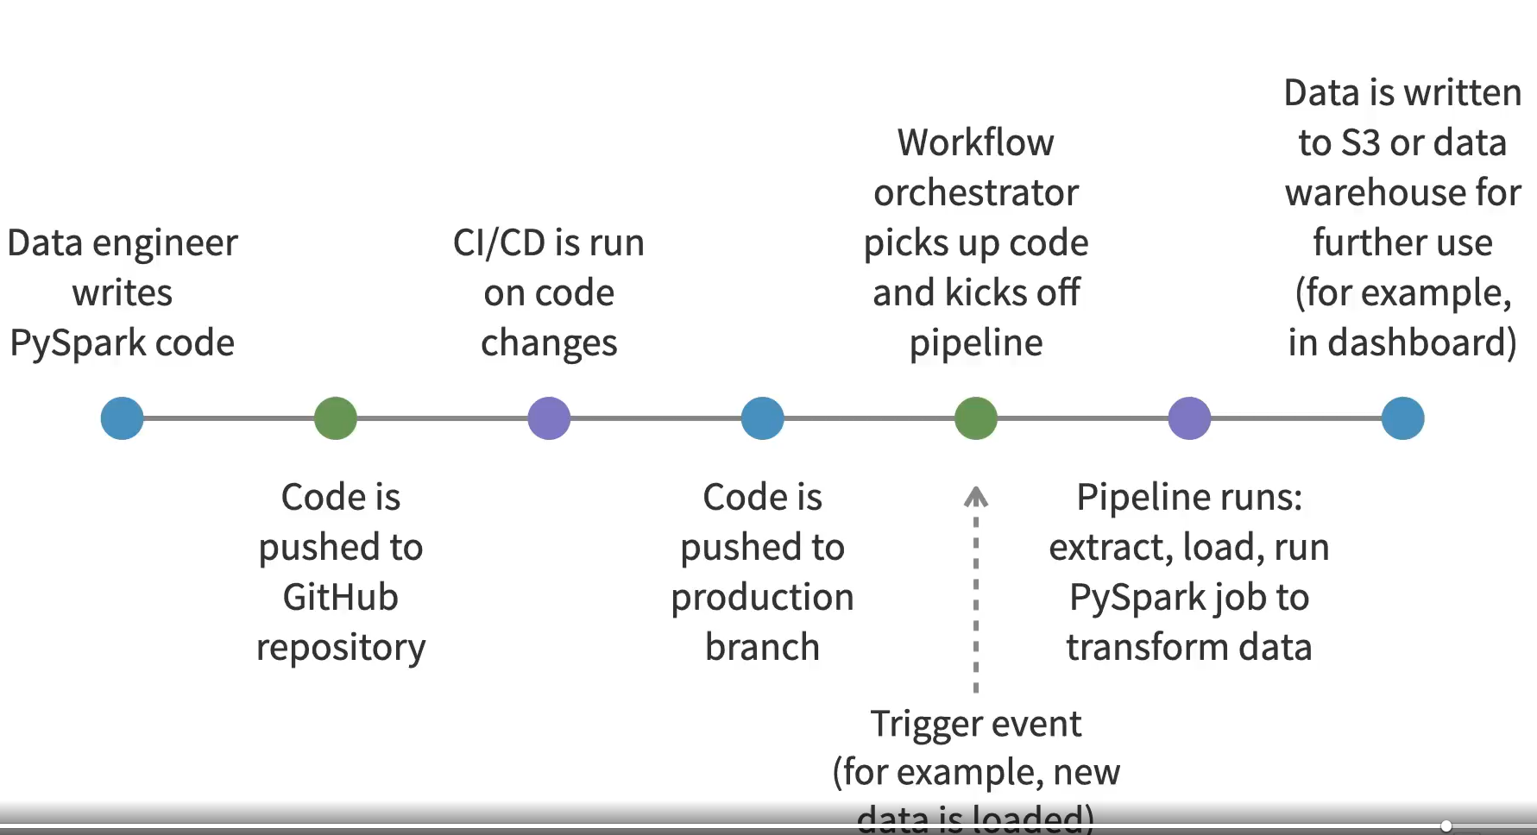
Cloud services :
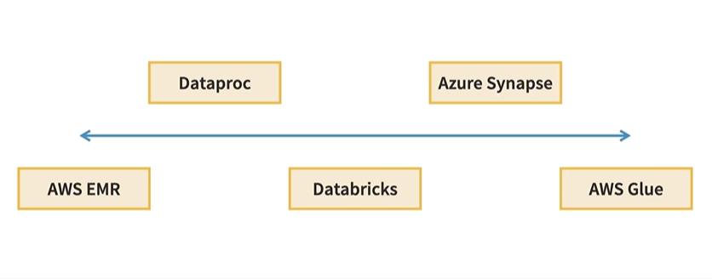
cloud platforms and services used for PySpark:
- AWS EMR: Runs Apache Spark on AWS.
- AWS Glue: Serverless data integration and ETL service that supports PySpark.
- Databricks: Managed data engineering and analytics platform built around Apache Spark.
- Google Cloud Dataproc: Managed service for running Spark and Hadoop workloads on Google Cloud.
- Azure Synapse Analytics: Analytics platform that supports Spark-based data processing.

